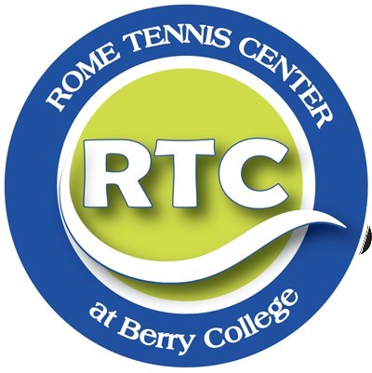
PLAY
ADULT
BEGINNERS
PRICE:
$40
General
$30 Wellness Partner
Discount
FOR
INFORMATION
Contact:
Bobby Walker
bwalker@rometenniscenter.com
If you have any
Questions
BENEFITING
Mind
-
Strategy
Body
-
Exercise
Soul
-
Social
Enjoy learning
A lifelong
Sport!
TENNIS ROME
WHEN

Nov. 4th-Dec. 16th 6:30pm – 8:00pm
WHERE

Rome Tennis Center at Berry College
100 Match Point Way
Rome, GA
30165
Participants receive –
Six classes, racket, registration in recreational play program, six months free play at RTCBC and downtown centers.

HTTPS://ROMETENNISCENTER.COM/

